**What’s the Wave?**

Individual Project

Justin Cancel

Towson University

Rebecca Broadwater

COSC 412 Fall 2020

Table of Contents

Part 1: **Introduction ..................................................................................................................... 3**

1.1 Project Overview ........................................................................................................... **3**

1.2 Project Deliverables ....................................................................................................... **3**

1.3 Evolution of the SPMP ................................................................................................... **3**

1.4 Reference Materials ....................................................................................................... **3**

1.5 Definitions and Acronyms .............................................................................................. **3**

Part 2: **Project Organization**

2.1 Process Model ............................................................................................................... **4**

2.2 Organizational Structure ................................................................................................. **4**

2.3 Organizational Interface ................................................................................................. **4**

2.4 Project Responsibilities .................................................................................................. **4**

Part 3: **Managerial Process**

3.1 Management Objectives and Priorities ............................................................................. **5**

3.2 Assumptions, Dependencies, and Constraints …........................................................ **5**

3.3 Risk Management .......................................................................................................... **5**

3.4 Monitoring and Controlling Mechanisms ......................................................................... **5**

3.5 Staffing Plan …........................................................................................................... **5**

Part 4: **Technical Process**

4.1 Methods, Tools, and Techniques ..................................................................................... **6**

4.2 Software Documentation ................................................................................................ **6**

4.3 Project Support Functions ............................................................................................... **6**

Part 5: **Description of Work Packages**

Work Breakdown Structure (WBS) ....................................................................................... **7**

Project Schedule .................................................................................................................. **7**

**Part 1: Introduction**

* 1. Project Overview

The goal of this project is to provide users with a safe space to meet other local users with similar interests. Current social media is based around the idea that you already have many friends to interact with online. What’s the Wave allows users to find other local users and interact with one another both online and in person. There will be a map where users can set pins on locations allowing other local users to interact with the pin and make plans. There will also be filters which allow users to limit those who can interact with their map pin. These filters will include: area radius, enrolled college students, age filter, gendered filter, and a friends list filter. The pins on the map will show a checkmark when one or more individuals confirm they are attending. Clicking the pin will prompt users to either confirm their attendance or message the individual who posted the pin for further details.

Furthermore, there will be a simple messaging system that will allow users to interact with one another. The messaging page will also be where users can manage their profile and friends list. The last page will be a feed of photos and videos which allows users to see what is currently going on locally. The same filters applied to the map will be provided for the feed page as well. When meeting new individuals in person safety is of the utmost importance and this will be main priority when developing the software.

1.2 Project Deliverables

* SPMP – 10/10/2020
* Tool Selection- 10/10/2020
* Use Cases- 10/10/2020
* Design Review Meeting- 10/10/2020
* Tool Selection Review Meeting- 10/10/2020
* Milestone Review- TBD
* System Test Plan- 11/3/2020
* Project Completion- 11/10/2020
* Project Presentation- 11/30/2020-12/7/2020

1.3 Evolution of the SPMP

The SPMP will evolve throughout the course of the project based on the customer’s requirements. After meeting with the customer on 10/10/2020 there will be a better understanding of the updates needed for the successful completion of the project.

1.4 Reference Materials

N/A

1.5 Definitions and Acronyms

Pin – A mark on the map which alerts users to local events in which they can respond to or register their attendance.

Feed – A page dedicated towards multimedia allowing users to visualize what is going on locally.

**Part 2: Project Organization**

2.1 Process Model

* Requirement Specification
* Use Case Analysis
* System Design and Integration
* Build Prototype
* Testing
* Refine Prototype
* Deliver Final Version

2.2 Organizational Structure

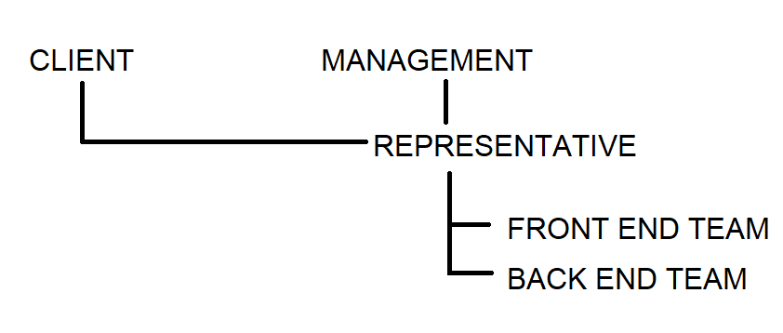

2.3 Organizational Interfaces

GitHub, Discord

2.4 Project Responsibilities

It is my responsibility as the sole developer to ensure that all code is functional and integrated properly. Furthermore, I must ensure that the code is as loosely coupled and tightly cohered as possible. Documentation will also be kept for progression and maintenance purposes.

**Part 3: Managerial Process**

3.1 Management Objectives and Priorities

Time management is the number one priority of this project. It is also vital that as progress is made all code functions together properly. Maintaining a balance between front and back end development is crucial as well as proper communication between the two.

3.2 Assumptions, Dependencies, and Constraints

This project is under a time constraint, it must be completed by November 10th the latest.

3.3 Risk Management

Risks will be assessed as they arise. From my understanding everything planned is achievable. However, there are no financial risks or risks for a company.

3.4 Monitoring and Controlling Mechanisms

Updates on the project will be provided via the link to its GitHub. This can be checked at any time.

3.5 Staffing Plan

Being it is an individual assignment I will be solely responsible for the production, documentation, testing and management of the project.

**Part 4: Technical Process**

4.1 Methods, Tools, and Techniques

Github, HTML, Java, Javascript, Database with SQL.

4.2 Software Documentation

Documentation updates will be made in the SPMP when necessary. Furthermore, a separate document will be kept for updating coding progression throughout the assignment. This is to find bugs based on when code was implemented and have a visual representation of progress before integration.

4.3 Project Support Functions

Consistent testing will ensure all functions are implemented correctly and function as anticipated. Meetings with the client will be made as necessary in order confirm the project is being completed correctly.

**Part 5: Description of Work Packages**

5.1 Work Breakdown Schedule (WBS)

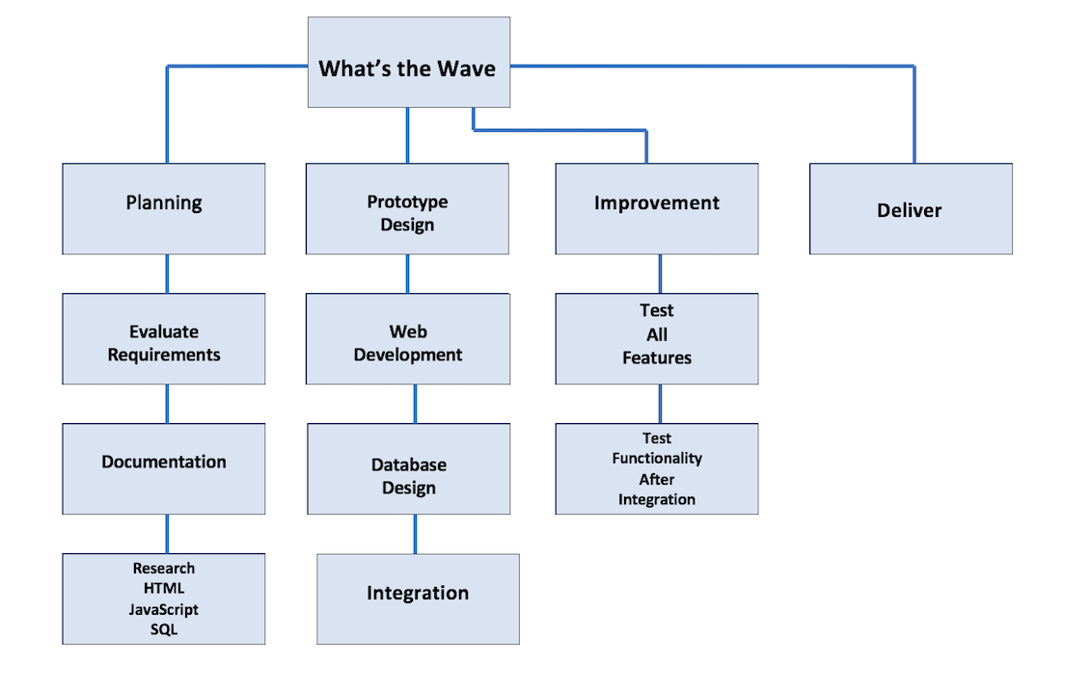

5.2 Project Schedule

Gantt Chart

